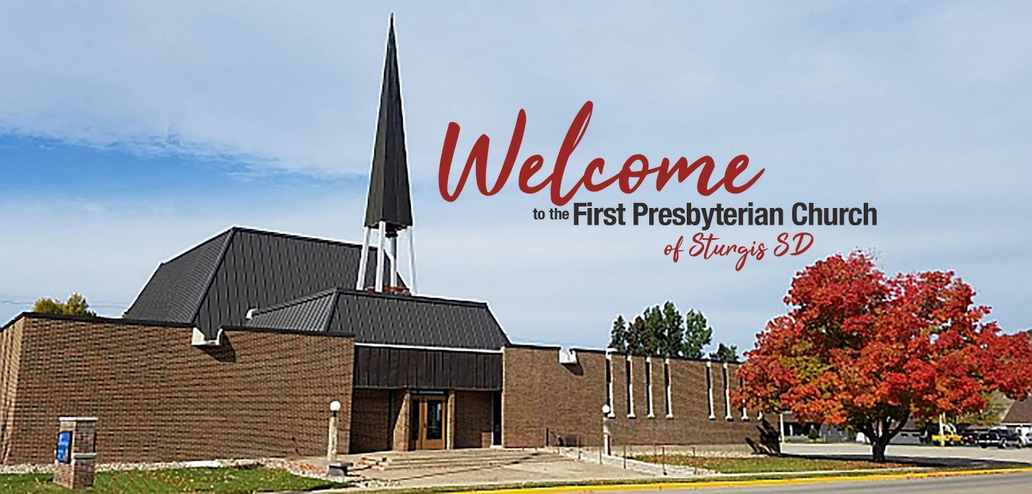

Sturgis First Presbyterian Church

Ministry Name:  First Presbyterian Church | Presbytery:  South Dakota | Synod:  Lakes and Prairies
Email and Phone Number  presbychsecretary@gmail.com  First Presbyterian Church | Sturgis SD | Facebook  605-347-2395 |  | Community Type:  Semi-Rural
Mailing Address:  1319 Junction Ave  Sturgis, SD 57785 |  | Congregation Size:  150-200
Average Worship Attendance  80-100 |  | Church Sunday School Attendance Approx. 12  Youth Group Approx. 15
Information about the Position
Position Requirements
Position type Employment status
Solo Pastor: Installed Full-time

Experience Language Requirements
Flexible English

Statement of Faith Open to a Clergy Couple
Yes Yes

Church Mission and Vision for a Pastor
The Mission of the First Presbyterian Church of Sturgis is living and sharing the message of the Gospel of Jesus with our church family and the world.
The First Presbyterian Church of Sturgis is looking for a pastor to shepherd us into the future. We look forward to the guidance and knowledge this person will bring to our congregation.
Tasks, duties, expectations, and responsibilities for the position:
`Worship and Spiritual development (plan and lead worship services) ` Session Moderator ` Comfort and aide the congregation` Community involvement ` Work with various committees` Supervise and manage day to day operations of the church` Be biblically and theologically grounded in God’s word` Lead study groups` Be a positive role model to all church members, especially our youth.
Compensation and Housing
Minimum Effective Salary Housing type
60,000 Housing allowance
Four weeks paid vacation
Two weeks paid study leave

