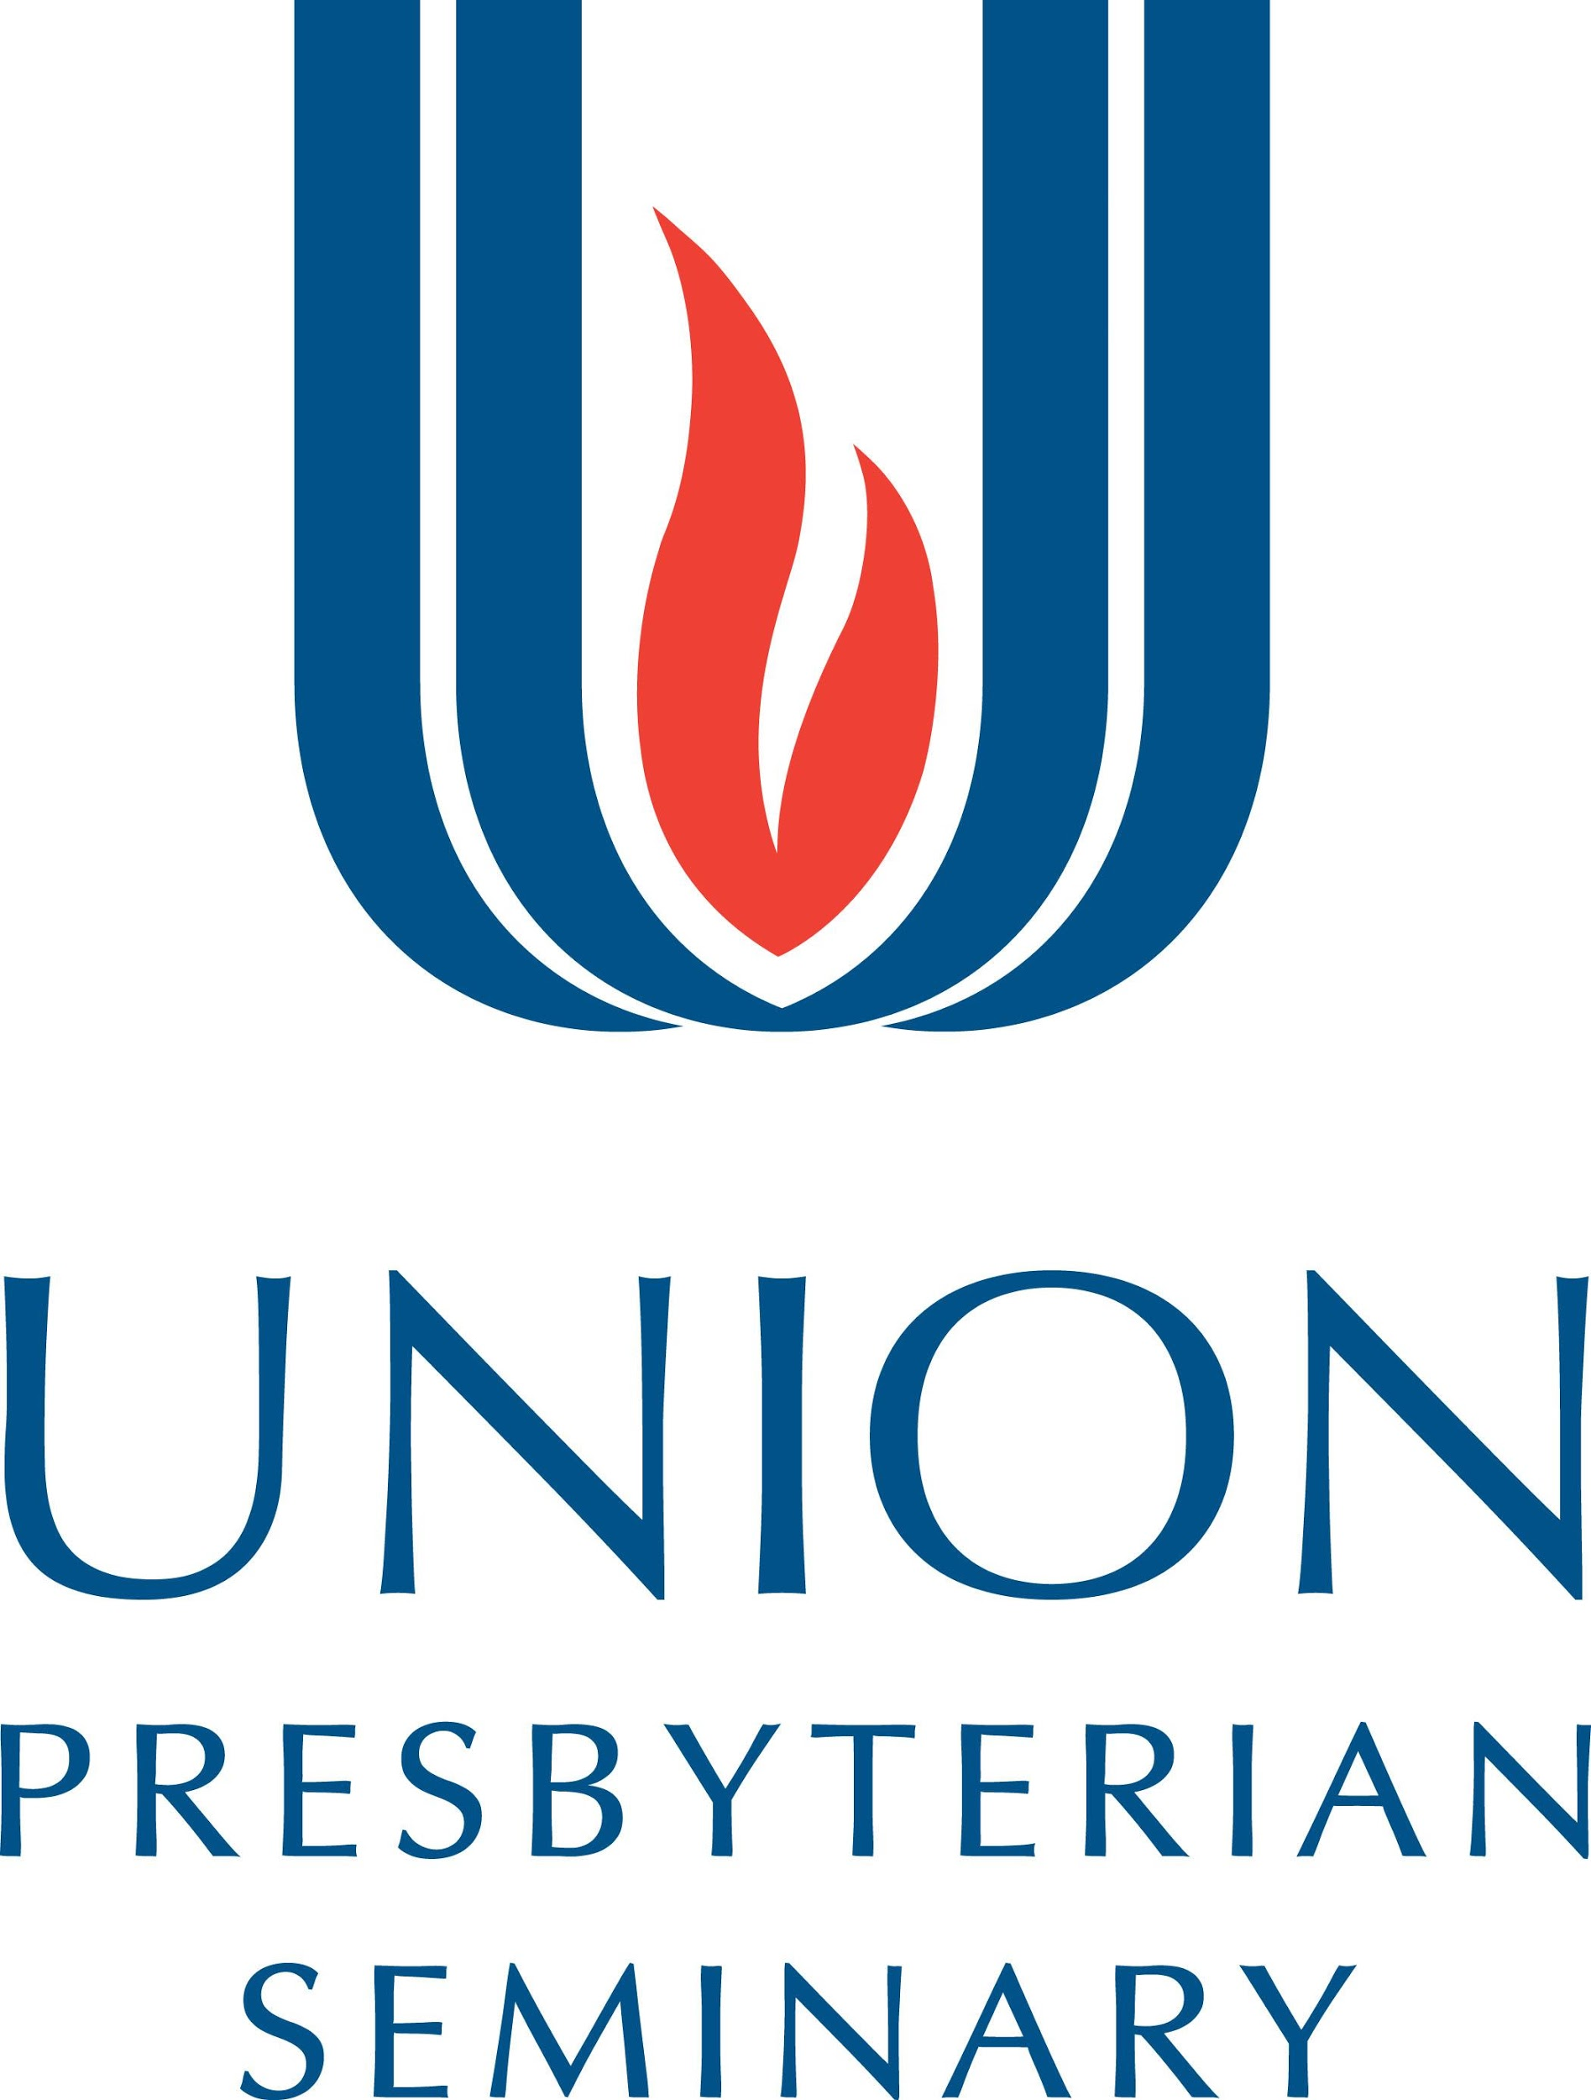

Supervised Ministry & Vocational Planning Office
3401 Brook Rd. Richmond VA 23227 (804)278-4220 dtripodi@upsem.edu
5141 Sharon Road Charlotte NC 28210 (980)636-1681 schang@upsem.edu

Final Assessment for (Student’s Name):
Process:
- The student and the supervisor each should prepare written drafts of their responses to the items below. The student and the supervisor should meet to exchange, review, and discuss their responses.
- The supervisor and the student should share their final responses before sending the complete report to the seminary instructor.
- The complete report consists of three components - Final assessment, Mentoring Team Feedback (1-2 pages), Spiritual Reflection Paper (1-2 pages) by the student.
- Do not send the parts in separately!
__________________________________________________________________________________________

Please have your supervisor return the completed final assessment form to your professor or instructor.

CHARLOTTE STUDENTS: Please have your supervisor email your completed final assessment to Dr. Sung Hee Chang at schang@upsem.edu Your supervisor may fax the final assessment with signatures to 980.636.1799

RICHMOND STUDENTS: Please have your supervisor email your completed final assessment to Rev. Dorothee Tripodi at dtripodi@upsem.edu

FAX Information:

We have read and discussed each other’s report.

Supervisor Name: _____________________________________

Supervisor Signature: __________________________________ Date: ______________

Student Name: __________________________________

Student Signature: ____________________________________ Date: ______________

Church/Agency Name: _________________________________________________________

Final Assessment Guidelines:

Supervisor:

- Describe and assess the student’s learning, skill development, and growth during this internship as they relate to the goals and objectives stated in the Learning Covenant.

- Identify the student’s professional development needs as they have emerged out of this internship.

- Discuss your perception of the student’s leadership style/gifts for ministry as they have manifested themselves in this internship.

- Describe and assess your supervisory relationship with the student.

- As you think back on the internship, what were some of the key ministerial/educational experiences that were incorporated into the process of supervision?

- Describe and assess this particular field setting as a context for theological field education.

- Include any additional comments you might have.

Student:

- Discuss your level of success in achieving each of your learning goals.

2. Identify and discuss at least three areas of growth that you experienced during this internship.

- Describe and assess the supervisory relationship during your internship. Include strengths and areas that you
Would have liked to explore further.

- Describe your relationship with the mentoring team members. What would have made the experience even better?

- Include any additional comments you might have.

Spiritual Practice Reflection Paper written by Student:

Write a one-to-two-page maximum page reflection on your chosen daily spiritual practice and reading (book, article, video, etc.) Attach it to this report.
__________________________________________________________________________________________
Mentoring Team Feedback:

Please attach a one-to-two-page maximum statement from your mentoring team that includes their:

- assessment of the mentoring relationship

- assessment of your strengths and professional development needs, and

- self-assessment of their work as a mentoring team.

Please send all three parts of the final assessment together to your professor or instructor.

QEP Form instructions: Please make sure that both, supervisor and student, fill in the following QEP form (pages 4-6):

Resource for Evaluation of Student Learning Outcomes
Supervisors and Students: As part of Union Presbyterian Seminary’s Quality Enhancement Plan, the faculty requests that both of you complete this form separately. The data will be used to provide us with additional information about student learning. This form is for seminary use only and WILL NOT be shared with the student’s denominational judicatory. If you have any comments about the contents or structure of the form, please feel free to share them at the end of this document.
Note: The three curricular roles (Practicing Theologian, Congregational Leader, and Community Witness) are defined in the Learning Agreement that you completed with the student.

Scale: 1 is low and 3 is high.
Please mark box below for those activities in which student was actually engaged during his/her supervised ministry internship. | Knowledge | Articulation | Performance
- Engaging Scripture  (Practicing Theologian, Congregational Leader, & Community Witness) | Exhibits a competent grasp of the original languages and content of material in order to understand scripture. | Interprets scripture in his or her preaching and/or writing in a faithful and culturally relevant manner. | Displays the ability to teach others to read and interpret scripture in a faithful and culturally relevant manner.
Circle Appropriate Level | ☐ 1 ☐ 2 ☐ 3 | ☐ 1 ☐ 2 ☐ 3 | ☐ 1 ☐ 2 ☐ 3
Comments | Click here to enter text.
- Worship  (Practicing Theologian, Congregational Leader, & Community Witness) | Exhibits a basic understanding of the key components of worship in his or her ecclesiastical tradition. | Organizes and leads worship in a manner faithful to his or her ecclesiastical tradition. | Preaches and leads worship in ways that discern the connections between biblical texts and the situations of contemporary listeners, calling them to respond faithfully to the claims of the gospel.
Circle Appropriate Level | ☐ 1 ☐ 2 ☐ 3 | ☐ 1 ☐ 2 ☐ 3 | ☐ 1 ☐ 2 ☐ 3
Comments | Click here to enter text.
- Declaring the Gospel outside of worship in an intellectually responsible manner.  (Practicing Theologian, Congregational Leader, & Community Witness) | Exhibits a competent understanding of the contemporary paradigms of knowledge and cultural assumptions in his or her ministry setting, including philosophical and scientific epistemologies. | Displays a capacity to theologically critique—positively and negatively—current paradigms of knowledge and cultural assumptions in his or her ministry setting by skillfully employing the combined resources of theology, church history, and biblical interpretation. | Using a variety of culturally and intellectually relevant idioms, communicates effectively outside of formal worship the gospel claims on the community of faith and the world beyond the church walls.
Circle Appropriate Level | ☐ 1 ☐ 2 ☐ 3 | ☐ 1 ☐ 2 ☐ 3 | ☐ 1 ☐ 2 ☐ 3
Comments | Click here to enter text.
- Communicating the Gospel outside of worship in Mission  (Practicing Theologian, Congregational Leader, & Community Witness) | Exhibits the ability to identify the gifts and graces for mission of members in his or her ministry situation. | Gives evidence of a facility for locating both the claims of the good news on the community of faith and any impediments to effecting Christian mission in his or her ministry setting. | Matches the gifts of members of the community of faith with the mission claims of the good news in his or her ministry situation in such a way as to inspire acts of Christian mission.
Circle Appropriate Level | ☐ 1 ☐ 2 ☐ 3 | ☐ 1 ☐ 2 ☐ 3 | ☐ 1 ☐ 2 ☐ 3
Comments | Click here to enter text.
- Pastoral Care  (Practicing Theologian, Congregational Leader, & Community Witness) | Exhibits empathy for the life situation of members of his or her community of faith. | Displays an ability to identify significant spiritual and/or physical needs for ministry in members of his or her ministry situation. | Employs elements of his or her theological education, his or her grasp of a member’s needs, and the resources of the church to pastorally address a member’s situation.
Circle Appropriate Level | ☐ 1 ☐ 2 ☐ 3 | ☐ 1 ☐ 2 ☐ 3 | ☐ 1 ☐ 2 ☐ 3
Comments | Click here to enter text.
- Community Leader  (Practicing Theologian, Congregational Leader, & Community Witness) | Exhibits a competent knowledge of the many religions and worldviews that shape the world in which the global church finds itself. | Can articulate competently the perspectives of the religions and worldviews that shape the particular situation in which he or she ministers. | Interacts constructively with other religious and community leaders in ways that are responsive to social needs and justice issues.
Circle Appropriate Level | ☐ 1 ☐ 2 ☐ 3 | ☐ 1 ☐ 2 ☐ 3 | ☐ 1 ☐ 2 ☐ 3
Comments | Click here to enter text.

Supervisor’s Name: Date:
Student’s Name: Date:
Internship Setting Name: City/State:

