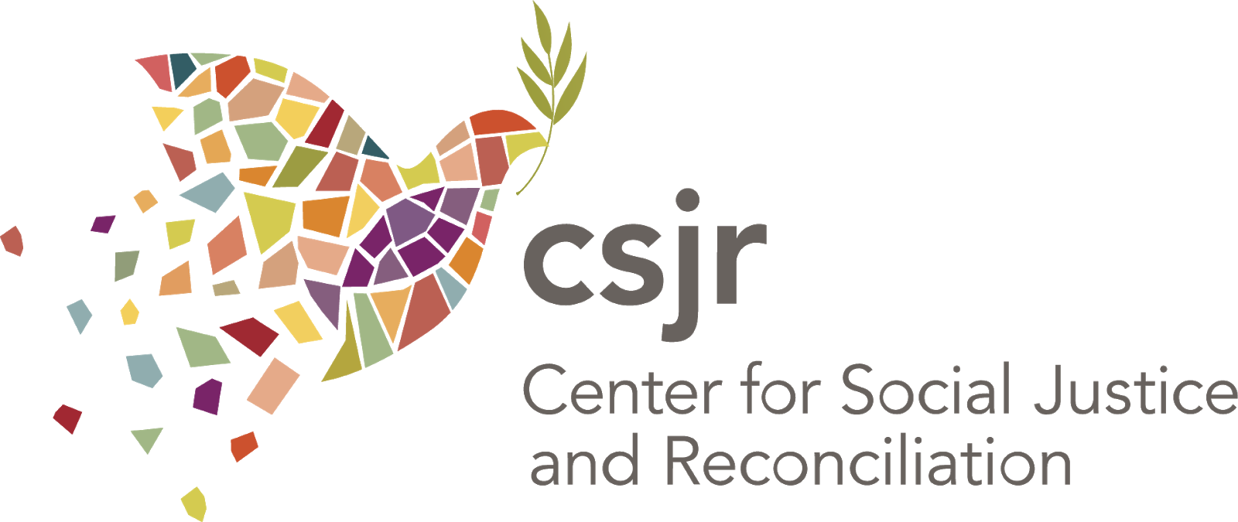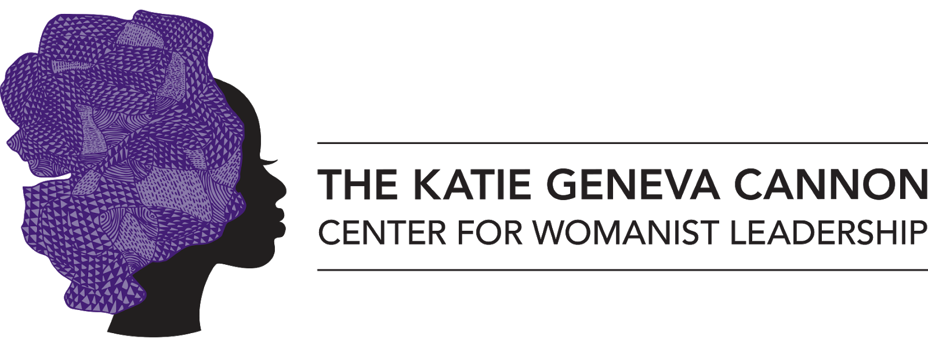

#SayHerName: Womanist Theology, Activism, and Movement Making
Womanist Resources

As discussed on Tuesday, March 16, 2021

Resources Mentioned During the Broadcast
Parable of the Sower by Octavia Butler

What's Faith Got to Do with It? Black Bodies / Christian Souls by Kelly Brown Douglas

The Sum of Us: What Racism Costs Everyone and How We Can Prosper Together
by Heather McGhee

Introducing Womanist Theology by Stephanie Y. Mitchem

In My Grandmother's House: Black Women, Faith, and the Stories We Inherit

by Yolanda Pierce

In Search of The Color Purple: The Story of an American Masterpiece Novel

by Salamishah Tillet

Troubling in My Soul (Bishop Henry McNeal Turner Studies in North American Black R)
edited by Emilie Townes

Just a Sister Away: A Womanist Vision of Women's Relationships in the Bible

by Renita J. Weems

Sisters in the Wilderness: The Challenge of Womanist Talk by Delores S. Williams

Song:
I Am Light by India Arie

Additional Resources:
Katie's Canon: Womanism and the Soul of the Black Community by Katie G. Cannon

Deeper Shades of Purple edited by Stacey Floyd-Thomas

Womanist Midrash by Wi Gafney

White Women's Christ, Black Women's Jesus by Jacquelyn Grant

