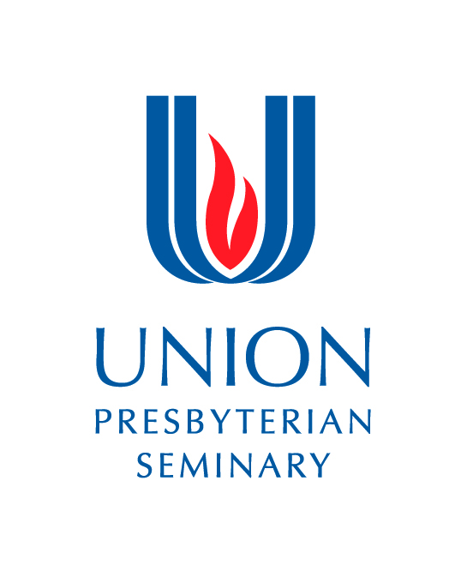
Supervised Ministry Site Application
Charlotte Campus 5141 Sharon Road Charlotte NC 28210
schang@upsem.edu 980.636.1681

Richmond Campus 3401 Brook Rd. Richmond VA 23227
dtripodi@upsem.edu 804.278.4220

Supervisor’s Last Name: Nyce First Name: Emily
Intern’s Last Name: First Name:

Congregation/Agency Site Name: Yaupon Place (of Union Presbyterian Seminary)

Supervisor’s Title: (e.g., Pastor, Program Director, DCE, Associate Pastor) Founder/Director
Supervisor’s Email: (Program information will be sent to this address.): emily@yauponplace.org

Street: 3401 Brook Rd
City/State/Zip: Richmond, VA 23227
Phone: 804-822-6483
Denomination: n/a
Please check all internship options you will offer:

Academic Year Parish/Non-Parish Internship Fall 3 credit hours Spring 3 credit hours
Summer Intensive Parish/Non-Parish Internship Richmond 6 credit hours
Spring II Intensive Parish/Non-Parish Internship Charlotte 6 credit-hours
Student-In-Ministry Year (SIM) 12 months 6 credit hours
Church in the World 3 credit hours Community Engagement
Evangelism
Interfaith
Site Description (up to 300 words)
(Include a brief understanding of mission, number of staff, and description of local community).
Yaupon Place is a developing center of Union Presbyterian Seminary, focused on the academic and community integration of their Westwood Tract park land. Yaupon Place envisions an equitably shared, multi-use greenspace in the Northside that cultivates collective peace through outdoor recreation, community storysharing and ecological partnerships. Currently, it is a one person staff with innumerous community and seminary support partners. Its community includes Union Presbyterian Seminary, Shalom Farms, and various other nonprofit partners like Virginia Interfaith Power and Light (VAIPL), the Northside YMCA, and earth workers eclectic, as well as resident neighbors and park users. Park users represent an incredibly diverse intersection of Richmonders (diverse in age, race, mobility, socioeconomic status, etc.), and their voices are at the heart of Yaupon Place’s visioning and programming alongside our program partners.

Supervisor Information (up to 400 words)
Include educational background; length of time served in ministry (congregational or agency work), any special interests or training you bring to your work, plans to go on Sabbatical or other absences that might occur during the internship.
Emily Nyce holds an undergraduate degree from Eastern Mennonite University in Religious & Intercultural Studies and a Master of Divinity from Union Presbyterian Seminary. Prior to seminary, Nyce worked professionally in churches, mostly through Mennonite Church USA, for seven years. Continued learning (outside of formal academic programs), professional development and community relationships are of high value to Nyce - attending many conferences, webinars and events that inform her interdisciplinary, holistic approach to her work. Nyce recently completed a Certificate in Community Storytelling from The Hearth, in Ashland, Oregon. She does not plan to have any absences during the 2022 Spring semester that would affect these part-time internships.

Description of Proposed Student Involvement (up to 400 words)
Describe the breadth and depth of ministry available for the intern’s participation. A student is expected to start and end the internship based on the academic term. The student in collaboration with the supervisor will develop learning goals at the beginning of the internship. These learning goals are subject to approval by the instructor. A student may not serve internships at their home congregation unless they serve on staff.

Two interns requested for Spring 2022:
- “Church in the World” 3 credits
Both interns will dedicate the majority of their time to working as part of a design team to create a community youth program for the summer of 2022 with the Northside YMCA and Virginia Interfaith Power and Light (VAIPL), an environmental justice organization. Because of VAIPL’s partnership and Yaupon Place’s values, this internship could count as “Interfaith” or “Community Engagement.” Interns will get to know the Northside community through the YMCA, help host stakeholder meetings, and help design a curriculum of enrichment activities using recreation and storytelling to connect children and youth to natural places, promote peace-building practices, and support reading skill retention during the summer months. Interns will also have opportunities to work alongside others at the seminary for potential grant funding as the program is developed.
- Both interns will have the opportunity to assist Yaupon Place with other program events happening during the spring semester:
  - The planning of an Ecological and Community Storytelling Festival for May of 2022. This would include assisting Nyce in coaching 5-6 community members as they practice sharing their 10-min stories for the festival as well as helping engage the surrounding Northside/Richmond community to bring local music, food, booths from eco organizations, media promotions etc. together for the festival. The theme will be environmental peace and justice. Interns should have an interest in learning about the power of community storytelling and equitable community gatherings, though no prior experience is necessary. Please see The Hearth’s website and listen to one of their community storytelling events to get a better sense of Yaupon Place’s model for our own unique festival.
  - A documentary event for seminary students exploring non-traditional community ministries by Derrick Weston of Food & Faith.
  - The Howie Center Events with (alum) Rev. Dr. Jen Ayres, featuring a partnership with Yaupon Place for engaging spiritual opportunities.
  - Monthly eco-events for the community outside at the park, in partnership with VAIPL (fire pit, eco-rituals, story sharing circles, etc.). Interns could potentially design and lead one month!

Time Requirements
The student is expected to serve:
- Fall/Spring term(200 hours/12 weeks): a minimum of 11-12 hours per week on site
- Charlotte Spring II and Richmond Summer (400 hours/10 weeks): a minimum of 35 hours per week on site
- Academic year internships begin in September and conclude in April
- Charlotte Spring II internships begin in late April and conclude late June (10 weeks)
- Richmond summer internships begin in early June and conclude in mid-August

Description of the Congregation’s/Site's Commitment to educating church and agency leaders
(up to 300 words)

Yaupon Place founded itself as a center of the seminary (and not as a separate nonprofit) truly because it is committed to the importance of theological education, grounded spirituality and vocational discernment for ministry-minded folk in this changing era of our public life together. Yaupon Place believes that this publically accessible, natural park setting provides a crucial space in our divided and divisive society, and practices like storytelling allow tensions to be held, societal boundaries to be more dissolved, and the human-community-environmental-Divine relationship to be restored. As an outdoor space in the midst of an on-going pandemic, Yaupon Place is also especially committed to programming and infrastructure that provides personal (physical, emotional, spiritual) and community (human and non-human) recreation. These goals can be achieved in endless, creative ways, and so Yaupon Place desires that interns bring their full selves and ideas to the table, with respect to others’, allowing the vision of Yaupon Place to grow organically as a collective vision. Yaupon Place is excited for interns’ personal stories to weave with its own, so that we might both be transformed together.

Stipend Information
UPSem suggests (but does not require) a stipend of $3500 for all internships except the SIM internship. If a stipend is available, please describe it below.

Because this is a Church in the World internship (not full-time summer work), Yaupon Place will provide a nice gift at the end of the term. That gift will be unique to the student intern’s interests and needs.
Other Considerations
(e.g., transportation, off-site supervisor, student’s denominational requirements, housing)

Supervisor Orientation
Each supervisor will complete a supervisor orientation as a prerequisite for supervising and mentoring a student. Orientations are generally held before the start of the term and may be available in online or on campus. The supervisor is required to attend an orientation for each internship.

Supervision
The supervisor and student will meet weekly for theological reflection, guidance, consultation and support. These meetings are separate from staff meetings. In this relationship of teaching and learning, both supervisor and student engage in mutual learning and growth.

Mentoring Team
The supervisor assists the student in selecting a mentoring team consisting of a minimum of three mentors from the congregation. The supervisor does not serve as part of the mentoring team. The student sets and communicates the agenda for each mentoring team meeting.

Academics
Supervised ministry is a required course at UPSem that receives academic credit. The student attends classes taught by the instructor either online or on campus in conjunction with the ministry at the setting. The supervisor is required to submit the Learning Covenant, the In-Process-Assessment and the Final Assessment on behalf of the student.

Ethical Standards and Expectations
It is expected that all the participants in Supervised Ministry courses (student, supervisor, mentoring team, instructor) are committed to the standards of ethics of UPSem, which promote the dignity of all persons. The Code of Ethics includes policies related to professional conduct, plagiarism, sexual misconduct, discrimination and confidentiality.

